I know, a lot of you have seen this one--it is a rerun I like to do every Easter. I wrote it while in St. Mary’s Cathedral at Mayo Clinic in one of my several stays there. Came out of Nowhere. Key letter the capital N.

**On Top of the Blood**

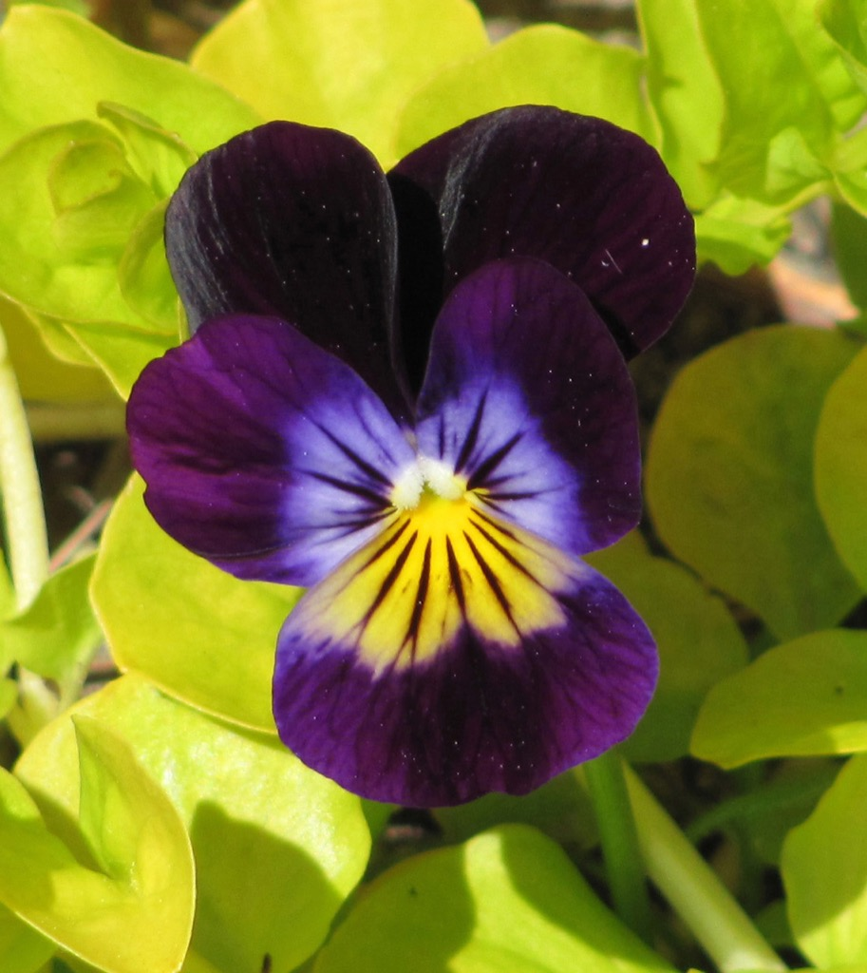

He was not a very bright man. Oh, he was intellectually smart enough in many ways, but he did not know many important things, like how to discern with inner peace.

He’d followed the Master from a distance for almost a year now. What made him come to this place on this day and during this stay, he did not know.

It was a such a great sadness, a very great sadness, the greatest sadness he’d ever known and he had known much sadness, like many, if not most of us, I suppose.

He watched as they hung him and killed him, the Master.

No longer would those words of hope come from that mouth, those words of love, those words that spoke ‘faith’, that seemed truer than any faith.

He stood there in the rain, oblivious to it and the fact it never ever rained this time of year.

He watched as they took the Master down, as the day grew darker and darker. It wasn’t long before the man was virtually alone, except for the bodies of the other people they had hung with the Master. No one took them down. It grew very dark. The only way he could see anything, was from the left over lightning, flashing periodically, illuminating all in eerie strobe-like fashion. The black sky, the brown ground, the sheen of water on everything, giving it all an iridescent and bluish glow like some ghostly cast.

When he was sure no one was coming back he walked down from his vantage point and up the small rise to where they hung him. He stood there at the base of the tree not even noticing the wetness on his face was not from the rain but from his own tears. He sagged down to his knees at the foot of the tree and felt despair of a kind never known to him before, overpower him.

“Why would they do such a thing to such a kind and gentle man?”

He never knew anyone kinder.

Soon he slumped over, first sitting on the hard rocky and clayish ground, now slippery like only mud made from clay is, eventually succumbing to the muck and the hardness and just lying down. With his eyes now even with the ground he saw, through the flashes of electric sky light, that the muck was laced with dark red.

“His blood,” he thought. “I am lying on his blood.”

And he wept and he wept and he wept, his tears mingling with the rain and the blood, the water and the blood. The never ending rain. “It seems like God Himself is crying…” was the last thought before the man fell into some sort of deep slumber on the very hard and rocky ground, slick sludgy clay and all.

When he woke the rain had stopped. It was clearly very early morning, the sun just starting to make its way over the distant steppes. He wasn’t quite sure where he was. There was a faint memory of wet and hard rocks and very pasty mud underneath his body and mixed in with all his clothes, but what he felt under him was none of those things.

He lay, it seemed, on a bed of fresh cut cedar, spongy and soft and smelling oh so delightful. It was the smell he noticed first and then, as he opened his eyes, he saw that he was indeed lying on such a bed. The tree was still there but the bed of cedar now surrounded its base and intermixed within the cedar were flowers wild of every kind and color and most of all, scent. Such incredibly beautiful smells!

He sat up and looked. As far as he could see the landscape was dotted with wildflowers, all arrayed in the beauty of Solomon and then some. Birds singing a symphony of ecstasy were everywhere.

In the distance he saw a figure walking towards him. He wondered if he should get up quickly and move off. He was still afraid that being associated with the Master could lead to his own torture and even death.

But it was all too surreal and pleasant. And the fear died within him. He waited for the figure to approach.

The figure, he thought it was a man, had on a hood, so he could not see his face, but he was clearly heading straight for him.

All grew very quiet, the birds who were singing joyously seemed to hush in some sign of great respect.

The man sat transfixed, unable to take his eyes off the approaching figure.

The figure came right up to him. Stood there for a second that seemed like year, such anticipation, such unknown thrill the man felt, then, reaching out its hand, offered the man a hand up.

The man reached out and took the offered hand and as he rose, the figure took its other hand and threw off the hood.

And then the figure, the Master, laughed, a laughter of the purest delight and joy the man had ever heard, and it struck right through his heart and into his soul.

The man was never the same again.

Clement P.X.